EX:6A | DATA VISUALIZATION USING POWER BI
DATE:

AIM:
To import, transform, analyze, and visualize data using Power BI Desktop and create interactive dashboards and reports for decision-making.

PROGRAM:

1)IMPORT EXCEL DATASET INTO POWER BI

ALGORITHM:
Step 1: Create the Store Sales dataset in Microsoft Excel.
Step 2: Save the dataset as an Excel file.
Step 3: Open Power BI Desktop.
Step 4: Select Home → Get Data → Excel Workbook.
Step 5: Browse and select the Excel dataset.
Step 6: Select the required worksheet and click Load.
Step 7: Verify the imported dataset.

OUTPUT:
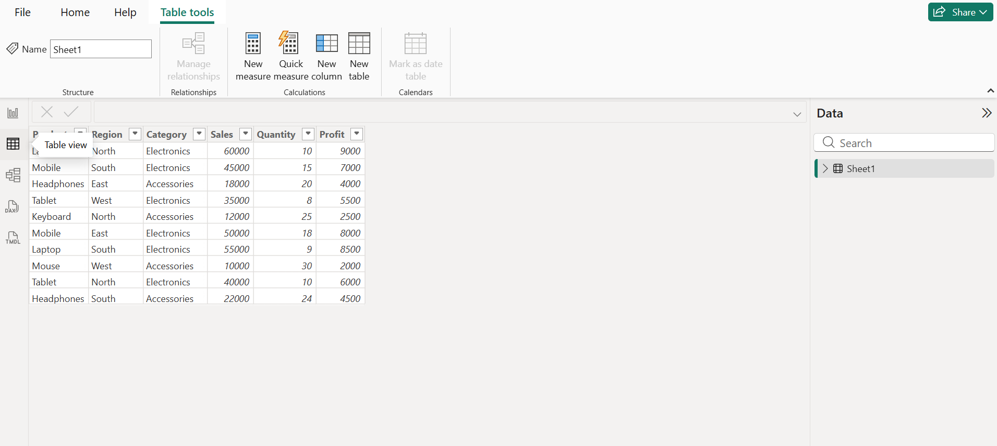

2)DATA TRANSFORMATION USING POWER QUERY

ALGORITHM:
Step 1: Select Home → Transform Data.
Step 2: Open Power Query Editor.
Step 3: Check the column names and data types.
Step 4: Remove duplicate records if present.
Step 5: Check and handle null or missing values.
Step 6: Rename the Sales column as Sales Amount.
Step 7: Select Close & Apply to load the transformed data.
OUTPUT:
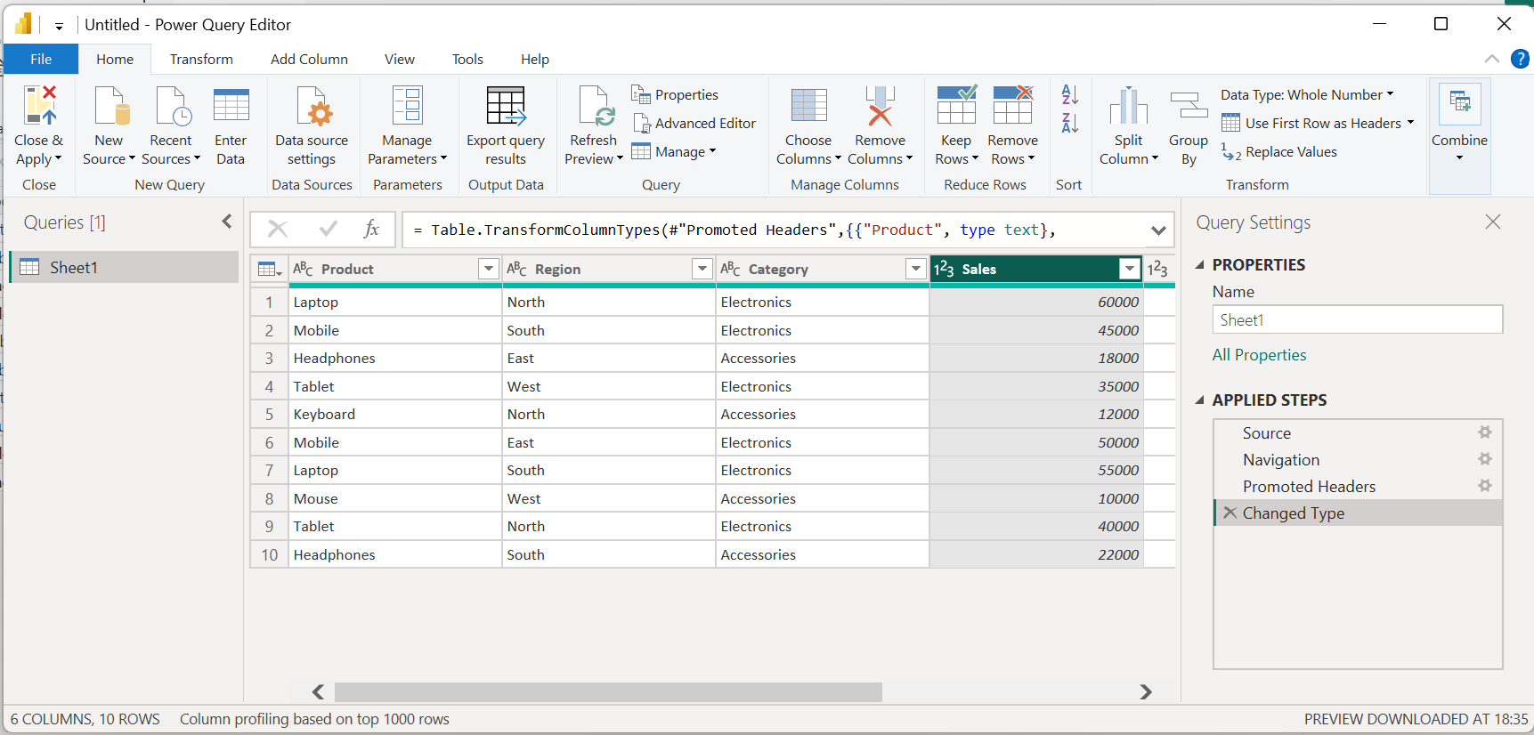

3)PRODUCT WISE SALES USING BAR CHART

ALGORITHM:
Step 1: Open Report View in Power BI.
Step 2: Select the Clustered Column Chart visualization.
Step 3: Drag Product to the X-axis.
Step 4: Drag Sales Amount to the Y-axis.
Step 5: Set the aggregation to Sum.
Step 6: Add the title Product-wise Sales.
Step 7: Format the chart and display the visualization.

OUTPUT:

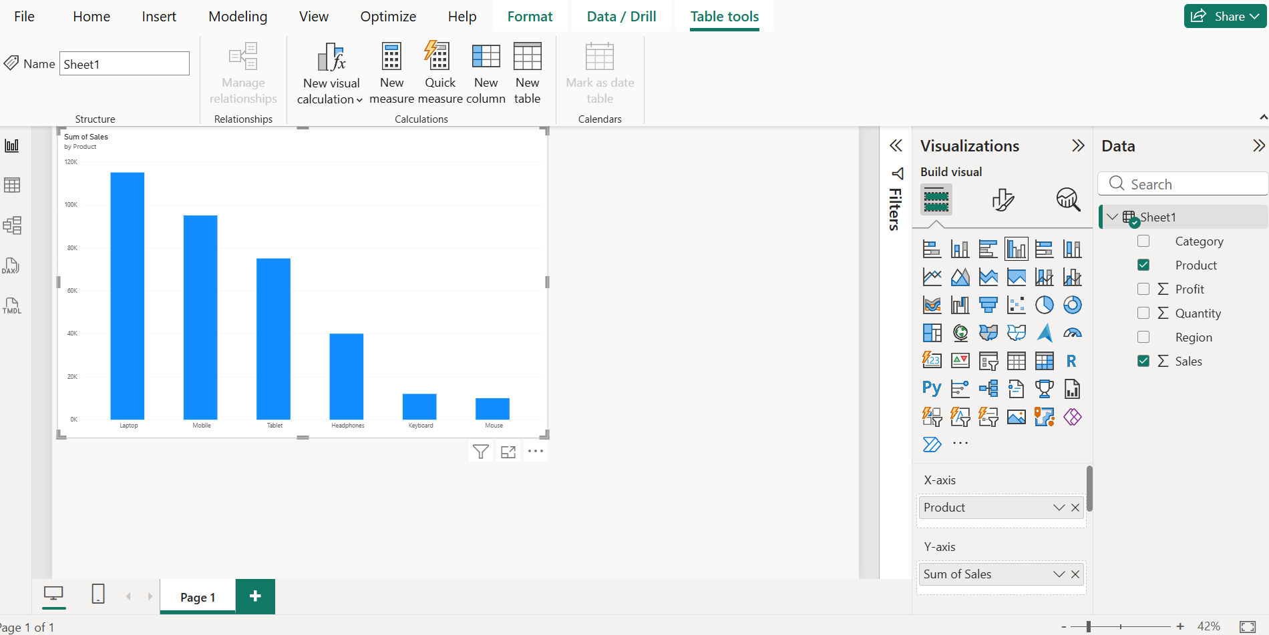

4)SALES CONTRIBUTION BY CATEGORY- PIE CHART:

ALGORITHM:
Step 1: Select the Pie Chart visualization.
Step 2: Drag Category to Legend.
Step 3: Drag Sales Amount to Values.
Step 4: Enable data labels.
Step 5: Add the title Sales Contribution by Category.
Step 6: Format the chart.
Step 7: Display the visualization.

OUTPUT:

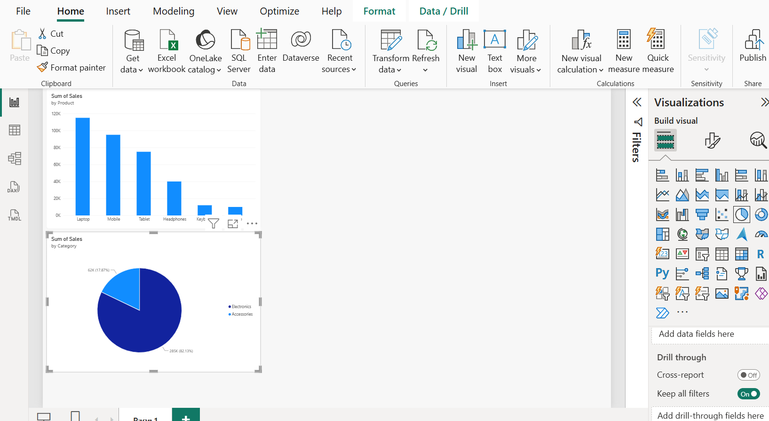

5)TOTAL SALES KPI CARD

ALGORITHM:
Step 1: Select the Card visualization.
Step 2: Drag Sales Amount to the Card.
Step 3: Set the aggregation to Sum.
Step 4: Display the total sales value.
Step 5: Add the title Total Sales.
Step 6: Format the Card visualization.
Expected value: ₹347,000

OUTPUT:

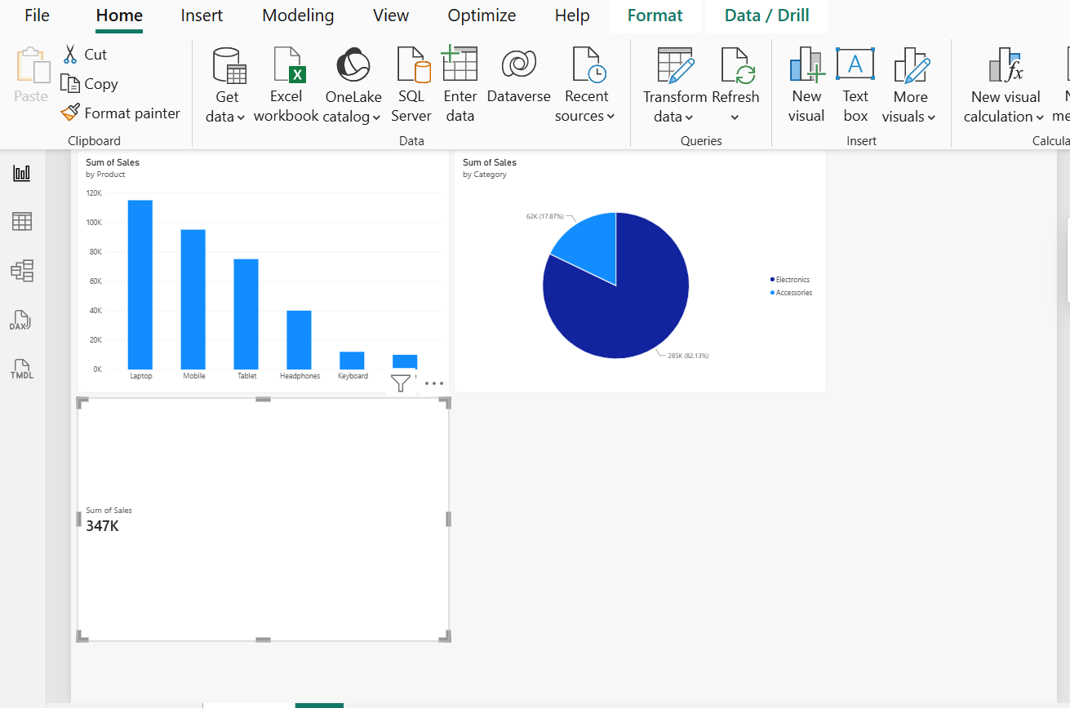

6)DAX MEASURES AND KPI CARD

ALGORITHM:
Step 1: Select Modeling → New Measure.
Step 2: Create a measure for Total Sales using SUM().
Step 3: Create a measure for Average Sales using AVERAGE().
Step 4: Create a measure for Maximum Sales using MAX().
Step 5: Create a measure for Minimum Sales using MIN().
Step 6: Display the calculated measures using Card visualizations.
Step 7: Verify the calculated values.

OUTPUT:
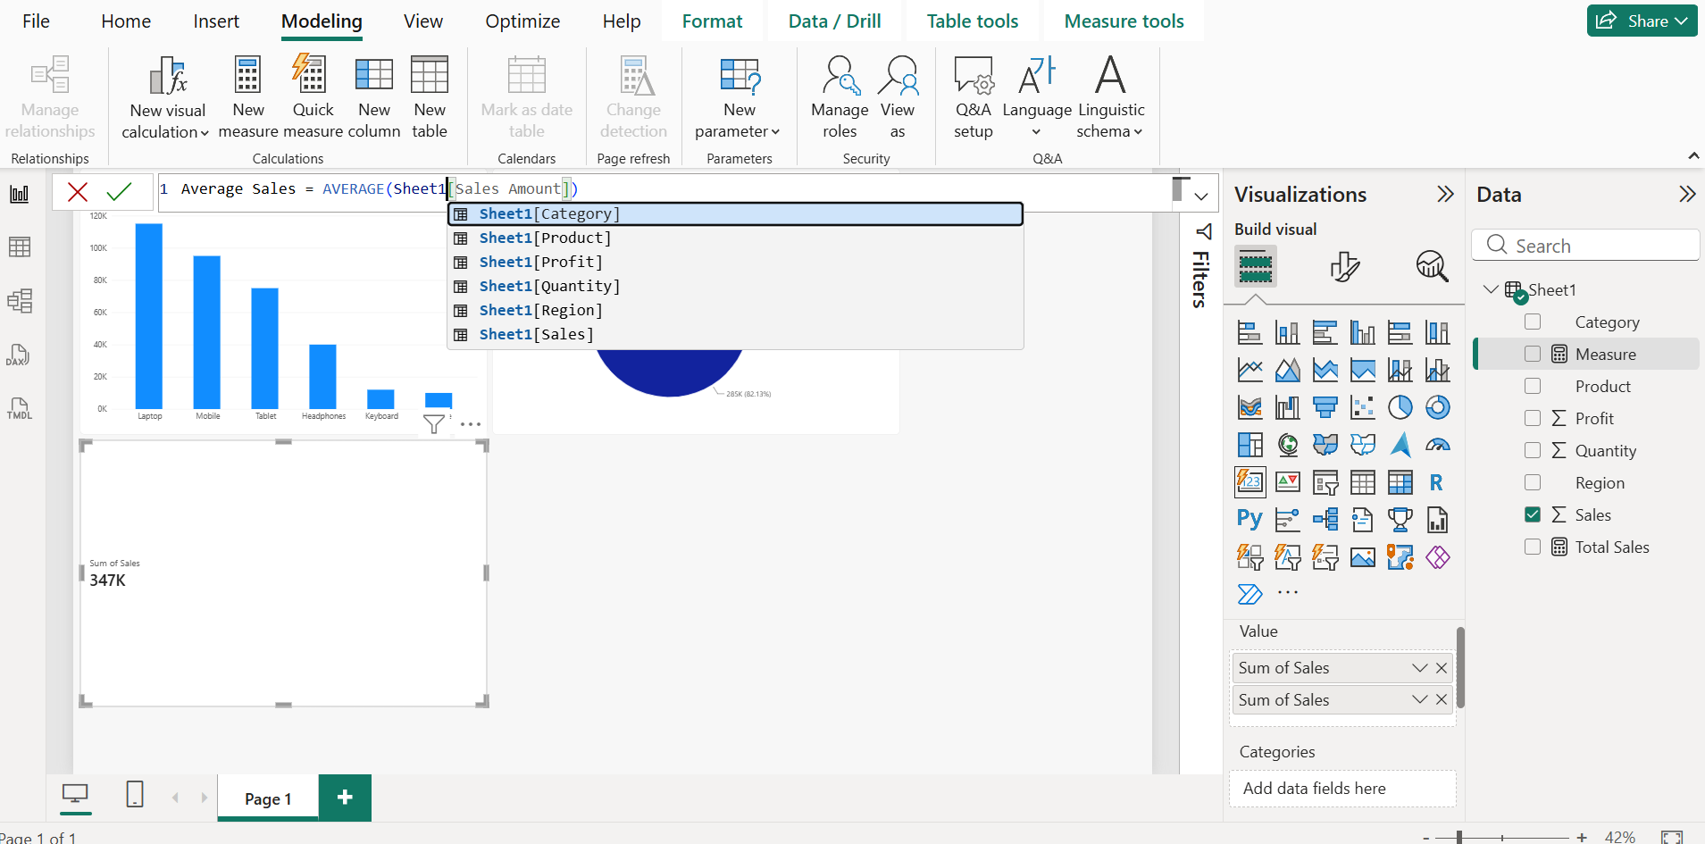

CREATE KPI CARDS FOR DAX MEASURES

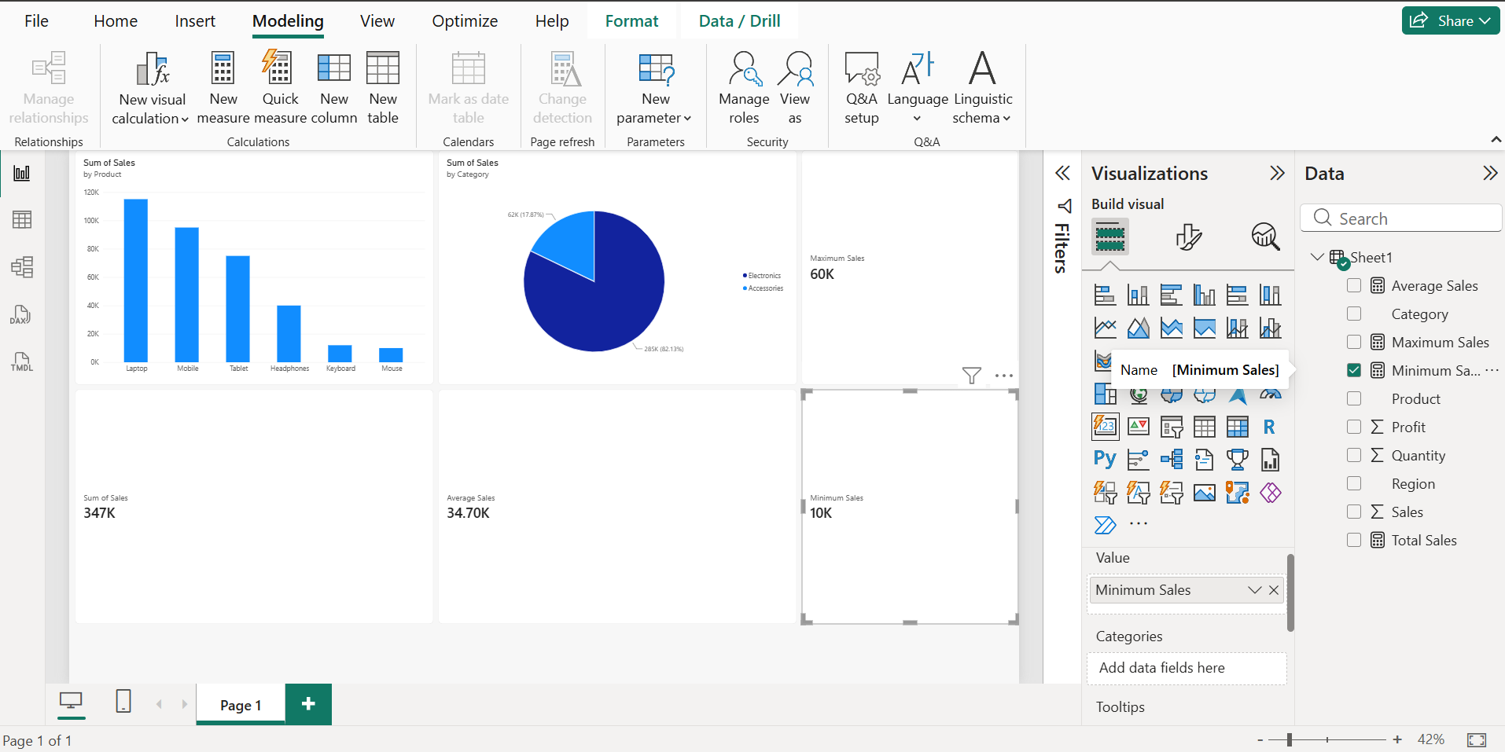

7)REGION SLICER FOR INTERACTIVE FILTERING

ALGORITHM:
Step 1: Select the Slicer visualization.
Step 2: Drag the Region field to the slicer.
Step 3: Display the available regions.
Step 4: Select a region such as North.
Step 5: Observe the changes in the dashboard visualizations.
Step 6: Clear the selection and test other regions.

OUTPUT:


CHANGE IN GRAPHS AFTER APPLYING THE FILTER:
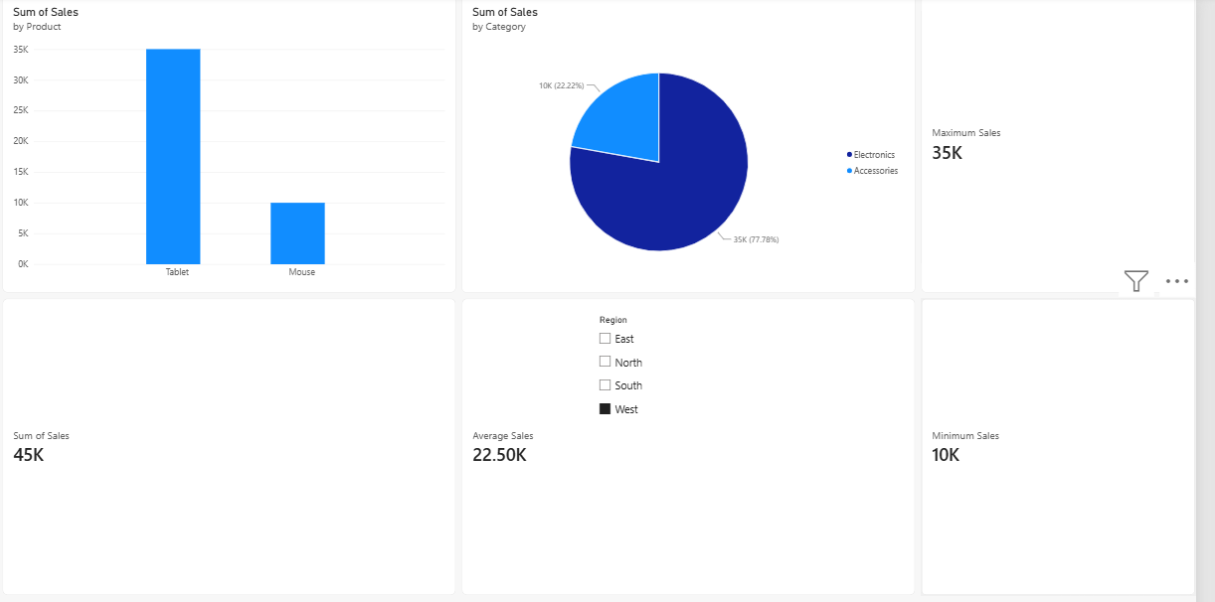

8)FINAL DASHBOARD

ALGORITHM:
Step 1: Create the required visualizations.
Step 2: Add KPI Cards for Total, Average, Maximum, and Minimum Sales.
Step 3: Add the Product-wise Sales Bar Chart.
Step 4: Add the Sales Contribution Pie Chart.
Step 5: Add the Region Slicer.
Step 6: Arrange all visualizations neatly on one report page.
Step 7: Apply filters and verify the interactive behavior.
Step 8: Add the dashboard title Store Sales Analysis Dashboard.
Step 9: Save the Power BI report

OUTPUT:
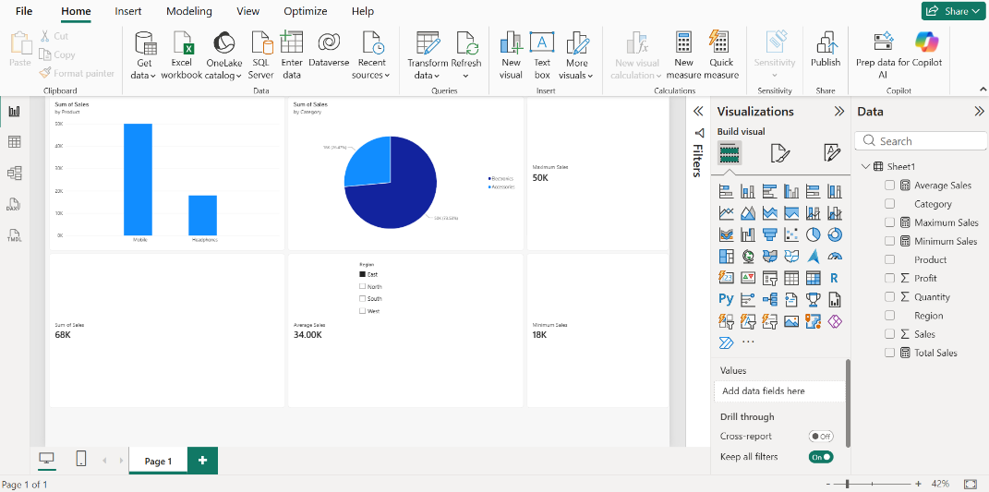

RESULT:
Thus, a Store Sales dataset was successfully created in Microsoft Excel and imported into Power BI. The data was transformed using Power Query, and bar chart, pie chart, KPI cards, DAX measures, and slicers were successfully created. Finally, an interactive Store Sales Analysis Dashboard was developed to visualize and analyze sales data effectively.

